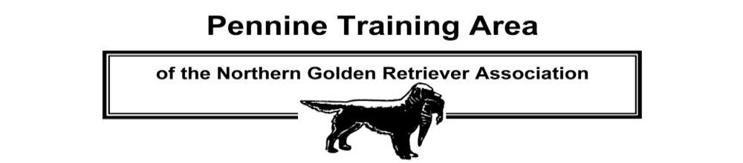
Membership Application Form (separate form for each applicant please)
Please indicate (tick one box only):

I wish to apply for membership of the Pennine Training Area 
I wish to renew my membership of the Pennine Training Area 

Please indicate (tick one box only):
I am also applying or have applied for membership of the Northern Golden Retriever Association 
I am already a member of the Northern Golden Retriever Association 

Title: Mr     Mrs     Ms  Miss  Other  (specify)

NAME (Block capitals please):

ADDRESS:

TOWN / CITY:

POSTCODE:

MOBILE NUMBER: TELEPHONE NO:

E-MAIL ADDRESS (please print clearly):

Due to the cost of administration and postage the Committee would ask that all members agree to opt-in to receiving correspondence by email. By submitting your details you are indicating your consent to receiving emails from us containing information about the activities of the Club, unless you tick this box  to indicate your objection to receiving these messages. You can also opt-out at any time by contacting the Club Secretary.

SIGNED: DATE:

ANNUAL MEMBERSHIP SUBSCRIPTION: ADULTS: £5.00 PER PERSON, JUNIORS (under 16): £1.00
MAKE CHEQUES PAYABLE TO “PENNINE TRAINING AREA”. PLEASE COMPLETE THIS APPLICATION FORM AND SEND IT WITH YOUR PAYMENT (CHEQUE ONLY) TO:

KAREN PARKINSON
38 PEEL MOUNT, KNUZDEN
BLACKBURN
BB1 2DU

The joint membership option only relates to membership of the NGRA, not the PTA. Each PTA member must complete a separate membership form although, if preferred, multiple PTA application forms sent together may be accompanied by a single cheque covering payment by all applicants.

ALL PTA MEMBERS MUST ALSO BE A MEMBER OF THE NORTHERN GOLDEN RETRIEVER ASSOCIATION (THE PTA’S PARENT CLUB), AND MUST ALSO AGREE TO ABIDE BY THE NGRA CODE OF ETHICS - SEE PENNINETRAININGAREA.ORG.UK OR CONTACT THE CLUB SECRETARY FOR DETAILS.

