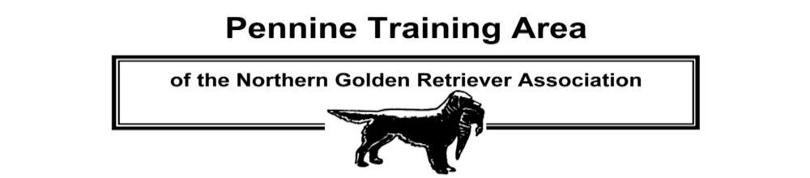
Please complete PTA and NGRA application forms - see pages 2 and 4

SECRETARY CHAIRMAN HON.TREASURER

Karen Parkinson Mike Pilling Christine Thompson
38 Peel Mount, Knuzden 332 Newbrook Road
Blackburn Atherton
BB1 2DU Manchester
Email: karenparkinson.pta@outlook.com

Committee Members
Mr J Benyon | Mrs L Whittaker | Mr G Lakey
Mr M Palmer | Mr M Nelson | Mr K Jackson
Mr M Kay  Mr N Whittaker | Mr P Murphy  Mr P Thompson | Mr A Telfair  Mrs C Thompson

The Pennine Training Area (PTA) was formed in 1960 and is part of the Northern Golden Retriever Association (NGRA). We are a Gundog Club run by the Committee (and members) for the members. The Club’s aim – to provide gundog training facilities and organise Working Tests – all within an informal club environment. All Retriever breeds are welcome to take part. There’s more information on our website – www.penninetrainingarea.org.uk.

There are a few basic rules to be observed during training classes:
- Bitches in season are not allowed at training classes or any other Event.
- Handlers under 11 years of age must obtain prior permission to take part from a Committee member, and should be accompanied by a Parent, Guardian, or responsible adult.
- All dogs must be kept on a lead, except when under a trainer’s instruction.

There is a fee for training of £5.00 per dog per class towards the cost of training equipment etc. Non Members are very welcome and will be charged a fee of £10.00 per dog per class. If you’d like to take part in the activities for the whole day, then bring a packed lunch. As the day is split you’ll only need to turn up for your particular class – although many members, once they’ve finished their ‘session’ (or before theirs is due to start) also assist the trainers – for example by throwing, placing, and collecting dummies.

Pennine Training Area - Annual Membership Fee
Adults: £5.00 per person, Junior members (under 16): £1.00. The annual subscription is payable on or before the 1st of January in any one year.
Please complete the PTA membership application form and send it with your payment (cheque only) to:
Karen Parkinson
38 Peel Mount, Knuzden
Blackburn
BB1 2DU
Cheques should be made payable to: “Pennine Training Area”. To save on postage costs - no receipt will be issued unless requested.
Members who have applied for or renewed their membership after the 1st of October in any year will qualify for membership up to the 31st of December of the following year. If the PTA subscription is not renewed by the 1st of March each year membership will lapse and the member’s name will be erased from the Club register. Any member who allows their membership to lapse will need to rejoin. There will however be no rejoining fee.
See pages 3 and 4 for NGRA subscription details and membership application form.
Membership Application Form (separate form for each applicant please)
Please indicate (tick one box only):

I wish to apply for membership of the Pennine Training Area 
I wish to renew my membership of the Pennine Training Area 

Please indicate (tick one box only):
I am also applying or have applied for membership of the Northern Golden Retriever Association 
I am already a member of the Northern Golden Retriever Association 

Title: Mr     Mrs     Ms  Miss  Other  (specify)

NAME (Block capitals please):

ADDRESS:

TOWN / CITY:

POSTCODE:

MOBILE NUMBER: TELEPHONE NO:

E-MAIL ADDRESS (please print clearly):

Due to the cost of administration and postage the Committee would ask that all members agree to opt-in to receiving correspondence by email. By submitting your details you are indicating your consent to receiving emails from us containing information about the activities of the Club, unless you tick this box  to indicate your objection to receiving these messages. You can also opt-out at any time by contacting the Club Secretary.

SIGNED: DATE:

ANNUAL MEMBERSHIP SUBSCRIPTION: ADULTS: £5.00 PER PERSON, JUNIORS (under 16): £1.00
MAKE CHEQUES PAYABLE TO “PENNINE TRAINING AREA”. PLEASE COMPLETE THIS APPLICATION FORM AND SEND IT WITH YOUR PAYMENT (CHEQUE ONLY) TO:

KAREN PARKINSON
38 PEEL MOUNT, KNUZDEN
BLACKBURN
BB1 2DU

The joint membership option only relates to membership of the NGRA, not the PTA. Each PTA member must complete a separate membership form although, if preferred, multiple PTA application forms sent together may be accompanied by a single cheque covering payment by all applicants.

ALL PTA MEMBERS MUST ALSO BE A MEMBER OF THE NORTHERN GOLDEN RETRIEVER ASSOCIATION (THE PTA’S PARENT CLUB), AND MUST ALSO AGREE TO ABIDE BY THE NGRA CODE OF ETHICS - SEE PENNINETRAININGAREA.ORG.UK OR CONTACT THE CLUB SECRETARY FOR DETAILS.

Data Protection: Membership details are held on computer in accordance with the General Data Protection Act (2018). This information is used solely for the mailing of association publications. The only disclosures are: (1) A list of members appears in the annual yearbook, the current edition of which is available only to fully paid up members. (2) A membership list is forwarded to the Kennel Club when requested. (as per Kennel Club regulations).

By signing above I/we are happy for the PTA to hold on its database my name, postal address, telephone numbers, email address.

- I/we understand that the information held on the PTA database will be used only by the PTA for the purposes of keeping me advised of events and activities run by the PTA.; - and, if so requested, this List will be made available to the KC.
- I/we may apply in writing to the General Secretary to advise me/us what information is held in my/our name(s) and this information must be provided within 40 days of the date of request; -
- that I/we may apply in writing to the General Secretary for my information, or any part of my information, to be deleted from the PTA database at any time.
- that the PTA will only hold my/our information for the duration of my/our membership of the Club.
- that I/we upon membership renewal will confirm my contact details (my name, postal address, telephone numbers, email address).

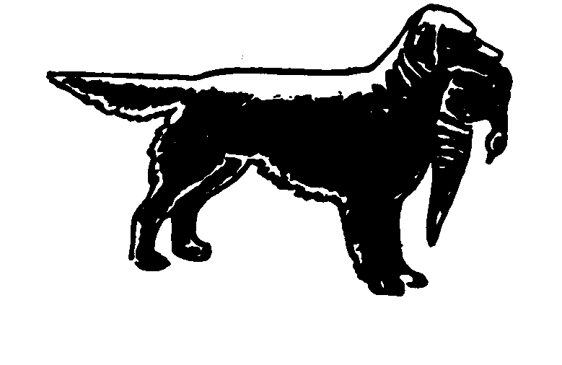
Northern Golden Retriever Association
Est. 1946

Treasurer  Mr John Newsham  1 Brazenhill Lane,  Haughton Stafford.ST18 9HS  01785 780149 | Chairman:  Mr Steven Crookes | President :  Mr Tony Hickinbottom
Show Secretary  Miss Angela Aulton  Littleworth House Farm  Alkmonton  Ashbourne  Derbyshire. DE6 3DG  01335 330660 | Field Trial Secretary  Mr Philip Wagland  33 Almond Grove  Worksop S80 1AU  01909 476024 | General Secretary  Mr Philip Smithies  52 Hollin Lane  Middleton  Manchester. M24 5EE  0161 653 3050

Dear Prospective Member,

Thank you for your enquiry about the Northern Golden Retriever Association, which was founded in 1946. The association runs field trials and shows, also through the Pennine Training Area runs gundog working tests and training classes. Currently the NGRA run up to six field trials per year: An open qualifying stake for Golden Retrievers, one all aged stakes for any variety Retrievers, two/three novice stakes for any variety Retrievers and a novice stake for Golden Retrievers.

The Pennine Training Area organises training sessions and gundog working tests, usually a novice and open test each year, plus matches against other clubs.

The NGRA holds a championship show and an open show for Golden Retrievers each year and has a website www.northerngoldenretriever.org.uk

Annual membership is £10.00 single or £12.00 joint. This is due on 1st January each year and membership will lapse if any outstanding subscription is not renewed by March the 1st.
Payment may be made by cheque or standing order. Overseas members may pay by International Bank Transfer (details can be obtained from the General Secretary or Treasurer).

Enclosed with application form is a copy of the Association’s Code of Ethics, all members of the NGRA must agree to abide by the Code of Ethics as laid down by the Association.

If you wish to join kindly complete the attached form and return to the General Secretary.

Yours sincerely
Philip Smithies
Mr P J Smithies
General Secretary
Northern Golden Retriever Association: Application for membership

[*Please delete as appropriate]

*I/we wish to join the Northern Golden Retriever Association. *I/we agree to abide by the Rules and Regulations and the Code of Ethics as laid down by the Association.

Name Membership type: *Single £10
*Joint £12
Address Telephone
Kennel Affix
Email address Signature[s]
*I/we enclose a cheque for £ for the first membership payment.

Please return your completed application form and cheque made payable to:-
“Northern Golden Retriever Association” to the Hon. General Secretary,
Mr P J Smithies, 52 Hollin Lane, Middleton, Manchester, M24 5EE

Membership will not become effective until approved by the Executive Committee but you will be eligible to participate in the Association’s events as a member. Voting rights will be conferred on membership acceptance of which you will be informed.

*I/we wish to receive the following schedules: [tick as appropriate]

Championship show Open Show Field Trial

Do you wish to pay future subscriptions by bankers order? Yes No

Do you wish to receive future information regarding our events etc by e-mail?
Yes No

If you do not wish your address to be published in the yearbook please contact the General Secretary.

Data Protection: Membership details are held on computer in accordance with the General Data Protection Act (2018). This information is used solely for the mailing of association publications. The only disclosures are: (1) A list of members appears in the annual yearbook, the current edition of which is available only to fully paid up members. (2) A membership list is forwarded to the Kennel Club when requested. (as per Kennel Club regulations).

By signing above I/we are happy for the NGRA to hold on its database my name, postal address, telephone numbers, email address.

- I/we understand that the information held on the NGRA database will be used only by the NGRA for the purposes of keeping me advised of events and activities run by the NGRA.; - and, if so requested, this List will be made available to the KC.
- I/we may apply in writing to the General Secretary to advise me/us what information is held in my/our name(s) and this information must be provided within 40 days of the date of request; -
- that I/we may apply in writing to the General Secretary for my information, or any part of my information, to be deleted from the NGRA database at any time.
- that the NGRA will only hold my/our information for the duration of my/our membership of the Club.
- that I/we upon membership renewal will confirm my contact details (my name, postal address, telephone numbers, email address).

NORTHERN GOLDEN RETRIEVER ASSOCIATION
GENERAL CODE OF ETHICS
All members of the Northern Golden Retriever Association undertake to abide by its general Code of Ethics.

Club members:

- Will properly house, feed, water and exercise all dogs under their care and arrange for appropriate veterinary attention if and when required.

- Will agree without reservation that any veterinary surgeon performing an operation on any of their dogs which alters the natural conformation of the animal, or who carries out a caesarean section on a bitch, may report such operation to the Kennel Club.

- Will agree that no healthy puppy will be culled. Puppies which may not conform to the Breed Standard should be placed in suitable homes.

- Will abide by all aspects of the Animal Welfare Act.

- Will not create demand for, nor supply, puppies that have been docked illegally.

- Will agree not to breed from a dog or bitch which could be in any way harmful to the dog or to the breed.

- Will not allow any of their dogs to roam at large or to cause a nuisance to neighbours or those carrying out official duties.

- Will ensure that their dogs wear properly tagged collars and will be kept leashed or under effective control when away from home.

- Will clean up after their dogs in public places or anywhere their dogs are being exhibited.

- Will only sell dogs where there is a reasonable expectation of a happy and healthy life and will help with the re-homing of a dog if the initial circumstances change.

- Will supply written details of all dietary requirements and give guidance concerning responsible ownership when placing dogs in a new home.

- Will ensure that all relevant Kennel Club documents are provided to the new owner when selling or transferring a dog, and will agree, in writing, to forward any relevant documents at the earliest opportunity, if not immediately available.

- Will not sell any dog to commercial dog wholesalers, retail pet dealers or directly or indirectly allow dogs to be given as a prize or donation in a competition of any kind. Will not sell by sale or auction Kennel Club registration certificates as stand alone items (not accompanying a dog).

- Will not knowingly misrepresent the characteristics of the breed nor falsely advertise dogs nor mislead any person regarding the health or quality of a dog.

- To refuse a stud service for bitches that are known to suffer from any known hereditary defects or are under 18 months old.

- Not to abuse bitches by over breeding, no Bitch is allowed to have more than four litters, cannot be bred from twice within a 12 month period and cannot be bred from under 18 months old, or if she has already had two litters by caesarean section

To understand that dogs grow old and may well require special care and attention and to know that your Golden is not just a dog but a friend and companion.

Breach of these provisions may result in expulsion from club membership, and/or disciplinary action by the Kennel Club and/or reporting to the relevant authorities for legal action, as appropriate.
KC/GJ January 2011

